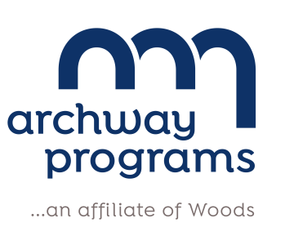

AHERA ANNUAL NOTICE TO PARENTS AND EMPLOYEES

January 2022

In accordance with the Asbestos Hazard Emergency Response Act (AHERA), maintenance personnel, building occupants, and/or legal guardians of students of Archway Programs must be notified annually of the activities regarding asbestos found in the School(s).

Archway Programs is located at 280 Jackson Rd., Atco, New Jersey. In the past year, Archway Programs has completed two (2) periodic surveillances, as required by AHERA. Awareness training for district maintenance personnel continues with recommended precautions regarding asbestos-containing materials (ACM) in accordance with AHERA.

Asbestos abatement projects/response actions were conducted as follows:

NO abatement/responses required in the 2021-2022 school year

All documentation for the abatement projects/response actions can be found in the District’s Asbestos Management Plan.

A copy of the most recent AHERA Management Plan can be found in the Main Office of the school(s), as well as the Maintenance Office, located at 210 Jackson Rd, Atco, NJ, and are available upon request for your review during school hours.

The Local Education Agency (LEA) Designee (as required per AHERA) for Archway Programs is Mr. Mike Smalley, Maintenance Director, who may be reached at (856) 767-5705, if there are any questions or concerns.

Sincerely,
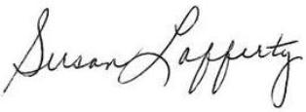
Susan Lafferty
Executive Director
Education

