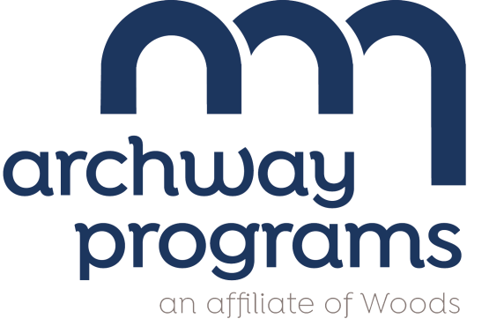
July 29, 2026

Dear Families,
Archway Programs is committed to ensuring that all our students start the day with a nutritious breakfast. This is why we are excited to inform you of our participation in the Breakfast After the Bell program, a part of the School Breakfast Program.
What is Breakfast After the Bell? Breakfast After the Bell is a food service model that offers breakfast after the start of the school day instead of before. Students will have an opportunity to eat breakfast during the beginning of class while their teachers take attendance, collect homework, or begin lessons as usual.
Why are we implementing Breakfast After the Bell? Serving breakfast after the bell gives more students the opportunity to eat breakfast at school. It removes common barriers our students may face and allows all students to start their day ready to learn. Studies have shown that access to school breakfast can positively impact student attendance, behavior, and academic performance.
When is breakfast? The school day begins at 8:30 am, and breakfast is served after the bell from 9:00 am to 9:30 am. Breakfast will be available to students delivered to the classroom during these times.
What is served for breakfast? School breakfast always includes milk, fruit and whole grains or meat/meat alternates. Even though breakfast items provided to students at school sometimes look like the same breakfast items found in stores, school breakfast items have more whole grains and less sugar, sodium, saturated fat and calories. School menus can be found at www.archwayprograms.org
If you have questions, please contact the Food Service Department at 856-767-5757 Ext. 218.
Sincerely,
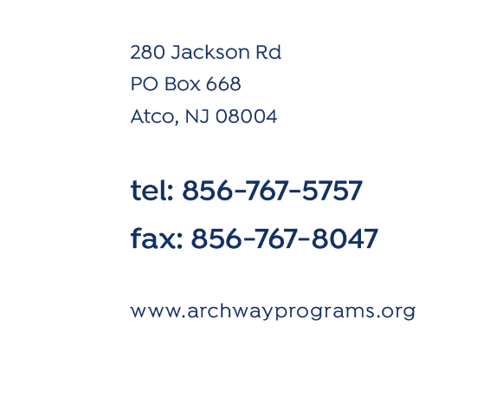
Mark Letiziano
Principal
